PARISH TEMPLATE
HOUSING MARKET REPORT
SEPTEMBER 2016
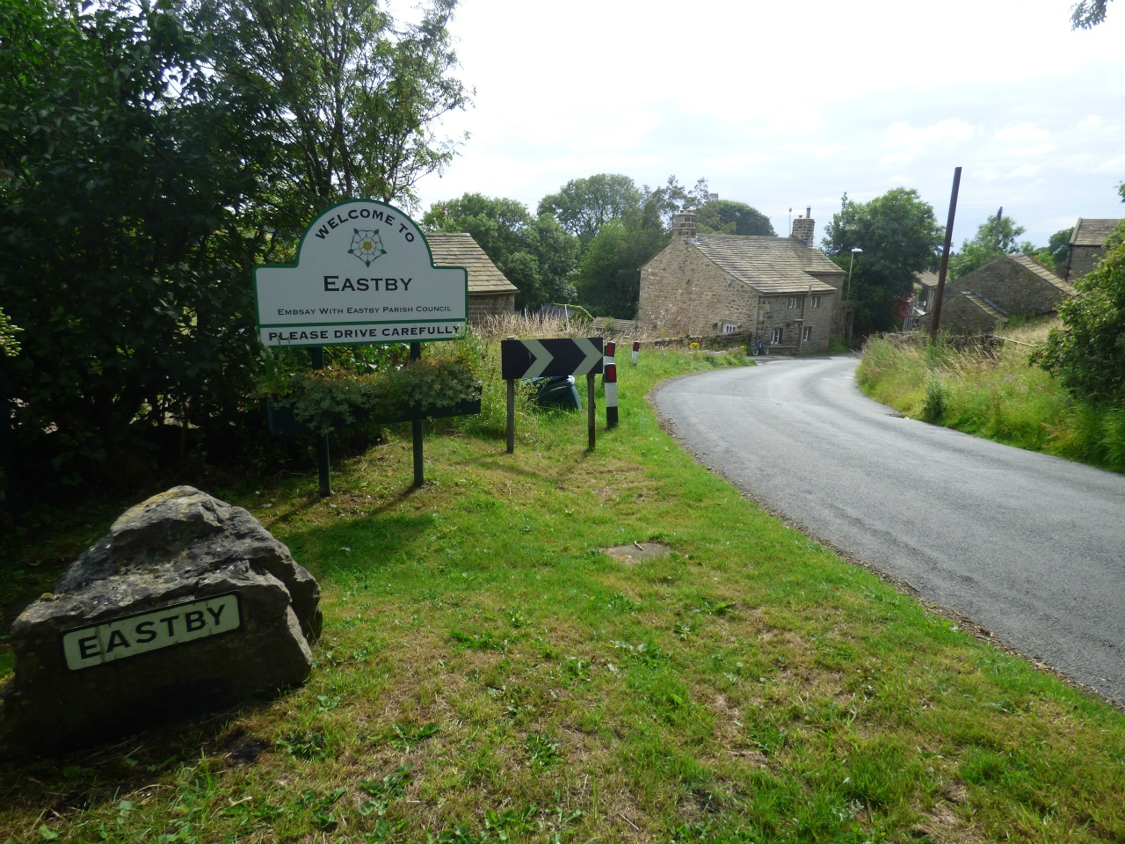
Emily Grogan
Rural Housing Enabler
Craven District Council

CONTENTS | PAGE
- INTRODUCTION

- POPULATION AND HOUSEHOLDS

- HOUSEHOLD CHARACTERISTICS

- DWELLING STOCK

- HOUSE PRICES AND PROPERTY SALES

- HOUSING NEED SUMMARY

- MORTGAGES AND LENDERS

- ECONOMY

- THE PLANNING CONTEXT

- CONCLUSION

- INTRODUCTION

Location – nearest towns/cities; transport links (road, rail, bus);

Map (example above)

Purpose of report

- POPULATION AND HOUSEHOLDS
According to the 2011 census, XX has a population of XX forming XX households. In 2001 there were a total of XX people living in the Ward and XX households, an increase of 7XX from 2001 to 2011. A total of XX people were aged 23-40 years and so would potentially qualify for starter homes if they were also first time buyers. (ons, census, key stats – need to add figures together to get same data range as HNS).

- HOUSEHOLD CHARACTERISTICS
Almost half (46%) of households within the XX are couples with no children.

Living arrangement of household | %
Couple with children | 22%
Couple without children | 46%
Single parent with children | 3%
Single parent without children | 3%
One person | 25%
Other (students) | 1%
(source – www.findahood.com)

Household Spaces | Number of households per property type
1 bedroom | 8%
2 bedroom | 23%
3 bedroom | 43%
4 bedroom | 20%
5 bedrooms or more | 6%
(source: ONS, housing, bedroom spaces)

The population of XX is generally healthy with only 16% describing their daily activities as being limited and indicating that they were in fair, bad or very bad health (including those claiming incapacity benefits). This is in comparison to 18% of respondents in the XX district as a whole. (ONS stats health and care stats, key figures and also long term health stats charts).

- DWELLING STOCK
Census data shows that. 69% of households live in either a detached or semi-detached property with only 8% living in a flat.

76% of homes in the Ward are owned outright or owned with a mortgage.

3.3% of properties in XX are vacant and a further 2% are either holiday homes or second homes.
(STREAM – housing and households - household spaces and accommodation type).

- HOUSE PRICES AND PROPERTY SALES

Asking prices for properties range from £169,950 to £379,000, and the average asking price is £250,040. The majority of homes on the market are 3 bed.

Rightmove Asking Prices as of June 2016

Address | Number of beds | Style of property | Price | Added to Rightmove

Assuming a 20% deposit is needed to secure a mortgage, this would mean that the average household would need to be earning approximately £57,152 per year to be able to afford to buy within the Ward (calculation is based on the average price £250,040 – 20% (deposit) x 3.5 (mortgage multiplier).

Rightmove Sold Prices
Address | Number of beds | Style of property | Price | Sold Date

The average price of sold properties is £223,055. Based on TOTAL average SOLD prices, a household would have needed an income of £50,984 per year in order to purchase a property between September 2015 and March 2016 (£223,055 – 20% deposit (£44,611) /3.5 mortgage multiplier).
XX currently has a total of 59 affordable properties, all rented and owned by a Registered Provider. Of these, 32 are flats, 19 are houses and 8 are bungalows. 40 of these properties are 1 beds, 8 are 2 beds and 11 are 3 beds. At the present time all these properties are currently tenanted.
At the present time (June 2016) there is only 1 property available to rent in XX. The property is being advertised with local lettings agent Belvoir.
Address | Number of beds | Style of property | Price per month | Added to market

Assuming that the average monthly spend on rent to be classified as affordable should be roughly 30% of a person’s income then, in order to rent ‘affordably’ in XX, a households income would need to be around £1,500 per month or £23,000 pa, taking into account deductions etc.
INCLUDE A QUOTE FROM ESTATE AGENT ABOUT THE PARISH AND DEMAND FOR HOUSING

- HOUSING NEED SURVEY SUMMARY

INCLUDE A SUMMARY OF HNS IF UNDERTAKEN
- MORTGAGES AND LENDERS

MORTGAGES PROVIDED IN DISTRICT RECENTLY- % of deposit, lender and loan amount if known

- ECONOMY

The majority of people who live in xx parish are employed in a skilled profession as shown in the table below.

Industry of employment | % of people employed
Managers and Directors | 15%
Professionals | 26%
Associate professionals | 12%
Administrative | 10%
Skilled Trade | 15%
Care, Leisure and personal service | 6%
Sales and customer service | 4%
Process, plant and machine operatives | 4%
Elementary Occupations | 8%

INDUSTRY SPECIFIC TO AREA – local employers, main area of employment

NUMBER OF PEOPLE RETIRED, EMPLOYED, CLAIMING BENEFITS

The average weekly wage in XX is £640 per week or £33,280 pa. This is above the average across XX which is £591 per week or £30,732 pa and the national average of £550 per week or £28,600 pa
(ONS data – topics, income, people and society –income model estimates – need to work out district and national averages using excel).

Based on the incomes noted the average wage in XX would not be sufficient enough to purchase the average priced property on the market or the average priced sold property between September 2015 and March 2016. According to the results of the Housing Needs Survey undertaken in May 2016 the average wage of those who respond was £29,411 per year. This is lower than the office of national statistics figures suggest and also further illustrates the inability of those who respondent to be able to financially afford to purchase a property within the Ward.

- THE PLANNING CONTEXT

XX falls into two local planning authorities. XX is in the process of producing a new Local Plan. The current Local Plan, which dates from 1999, is still being used. The new Local Plan, when adopted, will replace the existing one and identify new sites for both housing and employment across the District.
Within the Ward of XX, taking into account the two local planning authorities above, there are a total of five sites being considered for housing land allocations.
The map below shows those sites that are currently under consideration by XX for housing allocations, as part of the local plan process. At the present time no land in the Ward is being considered for employment allocations.

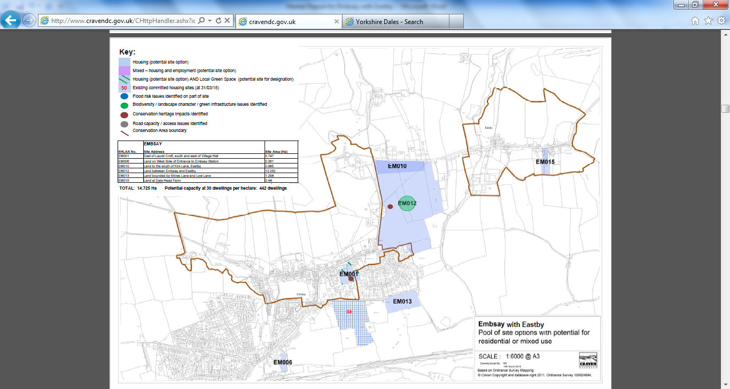

- CONCLUSION

