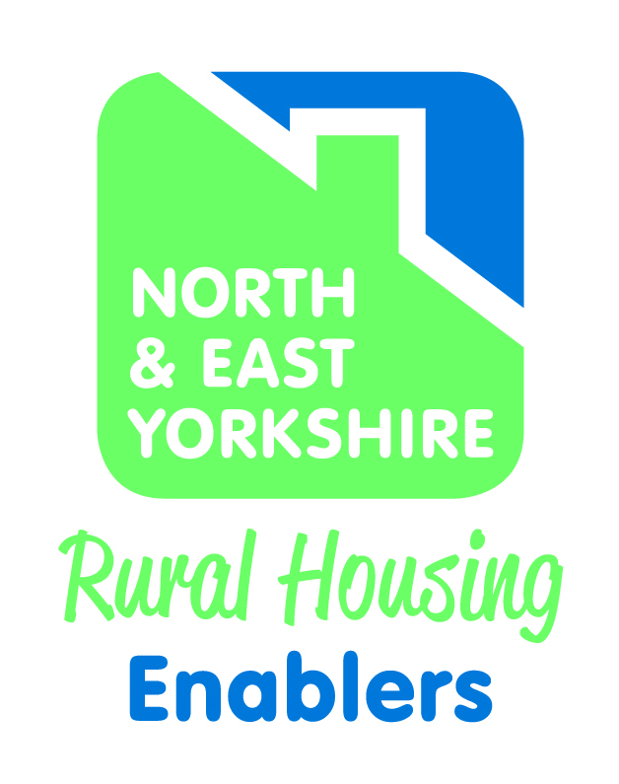

PARISH TEMPLATE
HOUSING NEEDS SURVEY REPORT
SEPTEMBER 2016
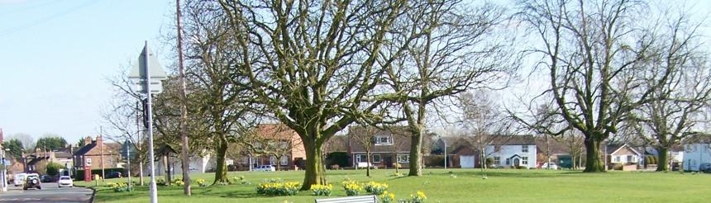

David Siddle
Rural Housing Enabler
East Riding of Yorkshire Council

CONTENTS | PAGE
- Parish Summary

- Introduction

- Aim

- Survey Methodology

- Housing Profile

- Key Findings

- Summary and Recommendations

Appendix 1 Survey Form

- PARISH SUMMARY

Location – nearest towns/cities; transport links (road, rail, bus);

Demographics – Population/Households

Village facilities – School; GP; shop(s); other commercial outlets; public house(s)

Community facilities – Recreation and sports clubs and grounds; other leisure activities/clubs; meeting rooms

Map (example below)

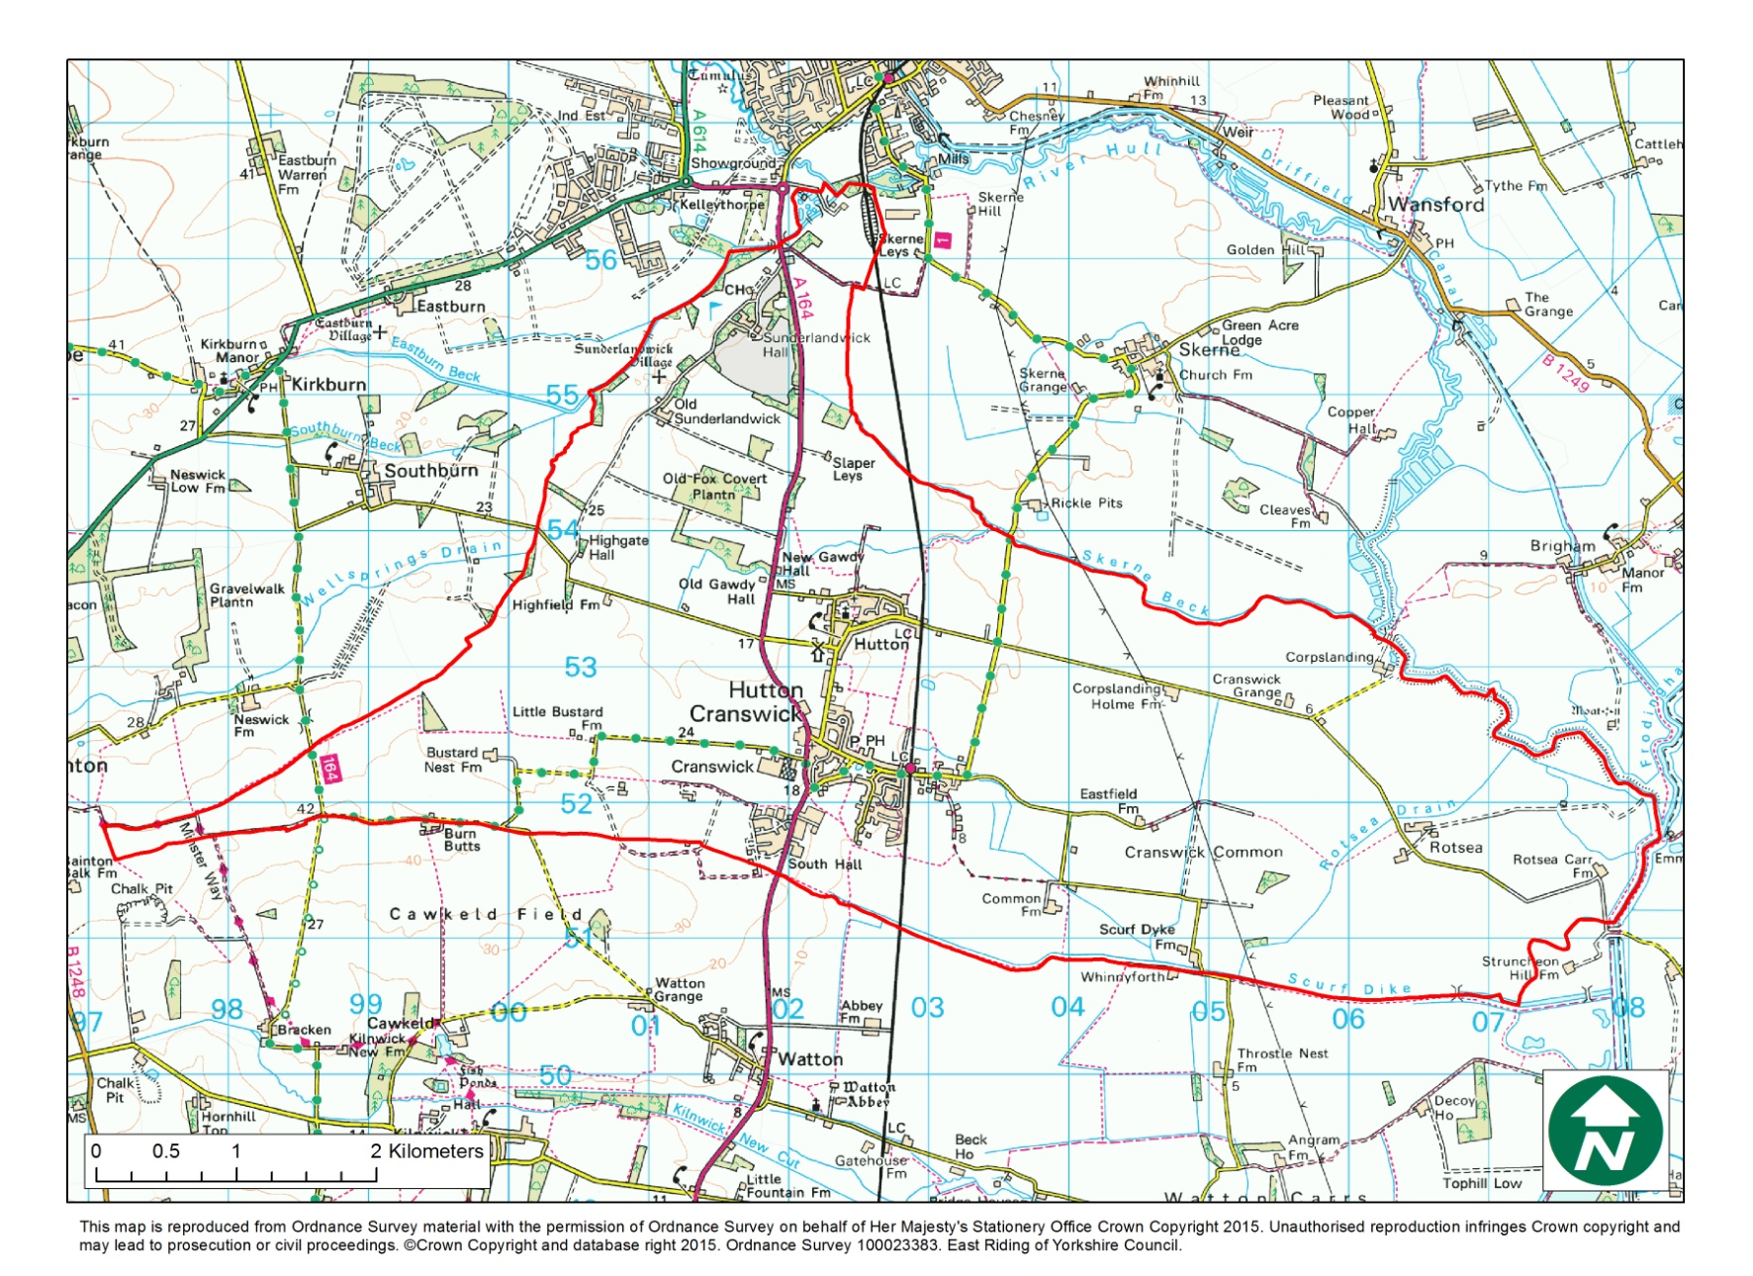

- INTRODUCTION

Affordable Housing is housing for either rent or low cost home ownership based on evidence of need, for those unable to afford market prices. In order to help identify if there is a need for Affordable Housing, the xxxx Rural Housing Enabler (RHE) has completed a housing needs survey in the parish of xxxxxxx. The RHE is hosted by xxxxxxxxxxxxx Council, and is part of the wider North Yorkshire and East Riding Rural Housing Enabler Network. The RHE works with a range oforganisations to help meet the housing needs of rural communities through the delivery of Affordable Housing.
Rural Housing Need Surveys record housing needs at a point in time and the RHE then uses this ‘snapshot’ of information as the basis of a report. This report can then be used as evidence to support a planning application for a small local Affordable Housing development. In the event that any new homes are built, priority would be given to applicants with a local connection to the parish ,through family, residence or work, at the time the properties are allocated.

- AIM
The aim of the Housing Needs Survey (HNS) was to find out whether local people (or people with a local connection) are in housing need and cannot access suitable housing to address their needs on the open market.
Housing ‘need’ can include issues other than merely the need for a home. It takes account of insecurity of tenure; affordability and housing that is unsuitable for the household due to its type or condition. It is different from housing demand because demand can normally be met though the housing market whereas need can usually only be met through some form of affordable (i.e. subsidised) housing.
This means that, in order to estimate the number of households in need, we want to identify households who do not have their own home or live in unsuitable housing and who cannot afford to meet their needs in the local market.
A household normally includes all who live in a particular house but can also include ‘newly forming ‘households who currently live with a larger family/household (e.g. adult children living with parents).

- SURVEY METHODOLOGY

In order to carry out the HNS, questionnaires with freepost return envelopes were distributed to every household in the Parish, as well as to all Choice Based Lettings applicants who have registered a local connection to the Parish of xxxxxxxx. The survey was distributed on xxxxxxx 2016 with a deadline to return the questionniaire of xxxxxxxx 2016.

The survey was also promoted on the xxxxxxxx Council website, Twitter and Facebook pages. Survey forms could also be completed online. Completed questionnaires were returned to the RHE for anlysis.

(A copy of the survey form is at Appendix 1)

- HOUSING PROFILE OF XXXXXXXXX

5.1 Population

According to the 2011 Census, xxxxx has a population of yyyy forming zzz households. In 2001 there were a total of yyy people living in the Ward and zzz households, an increase of a% from 2001 to 2011. The age of the population of xxxx is skewed towards older people, with b% of the population aged over 60. Only c% of the population are aged between 19 and 30 years, as illustrated on the chart below. A total of 293 people were aged 23-40 years and so would potentially qualify for Starter Homes (see definition below) if they were also first time buyers. (ONS, census, key stats – need to add figures together to get same data range as HNS).

The population of xxxxx is generally healthy with only e% describing their daily activities as being limited and indicating that they were in fair, bad or very bad health (including those claiming incapacity benefits). This is in comparison to f% of respondents in the xxx local authority area as a whole. (ONS stats health and care stats, key figures and also long term health stats charts).

5.2 Household Characteristics
Almost half (d%) of households within xxxx are couples with no children. One quarter of all households are also single person households.

Living arrangement of household | %
Couple with children
Couple without children
Single parent with children
Single parent without children
One person
Other (students)
(Source – www.findahood.com)

Household Spaces | Number of households per property type
1 bedroom
2 bedroom
3 bedroom
4 bedroom
5 bedrooms or more
(source: ONS, housing, bedroom spaces)
Insert comment on these tables

5.3 Dwelling Stock
Census data shows that x% of households live in either a detached or semi-detached property with only y% living in a flat.

In terms of tenure, 76% of homes in the parish are owned outright or with a mortgage. This is comparable to both the xxx District and the York and North Yorkshire region where owned outright rates and owned with a mortgage are 73% and 64% respectively. (note – check these figures!)

a% of properties in xxx are vacant and a further b% are either holiday homes or second homes. (STREAM – housing and households - household spaces and accommodation type).

5.4 House Prices

Asking prices for properties currently on the market within the parish range from £x to £y, and the average asking price is £250,040. This corresponds with information from the 2015 SHMA, which indicates a median house price for xxxx of £250,000.

Rightmove Asking Prices as of XXXX 2016

Address | Number of beds | property Type | Price | Added to Rightmove

Assuming a 20% deposit is needed to secure a mortgage, this would mean that the average household would need to be earning approximately £57,152 per year to be able to afford to buy within the parish (calculation is based on the average price £250,040 – 20% (deposit) x 3.5 (mortgage multiplier).

Rightmove Sold Prices
Address | Number of beds | Style of property | Price | Sold Date

The average price of sold properties is £xxx. Based on total average sold prices, a household would have needed an income of £xxx per year in order to purchase a property between September 2015 and March 2016 (£223,055 – 20% deposit (£44,611) /3.5 mortgage multiplier)
It is also notable that the majority of properties on the market are 3 bed homes, with fewer 1 and 2 bed properties available.

At the present time (June 2016) there are only y property/ies available to rent privately in XX. The property is being advertised with local lettings agent zzzz
Address | Number of beds | Style of property | Price per month | Added to market

Assuming that the average monthly spend on rent to be classified as affordable should be roughly 30% of a person’s income then, in order to rent ‘affordably’ in XX, a households’ income would need to be around £xxx per month or £xxxx pa, taking into account deductions etc.

The parish of xxxx currently has a total of yy affordable properties, all rented and owned by a Registered Provider. Of these, ww are flats, zz are houses and qq are bungalows. xx of these properties are 1 beds, yy are 2 beds and zz are 3 beds. At the present time all these properties are currently tenanted.

- KEY FINDINGS FROM THE HOUSING NEEDS SURVEY

A total of xx survey forms were returned by the deadline. xx were paper responses and xx were completed electronically.

  - Local Connection

xx respondents specified a local connection.

- x respondents currently live in xxxxxxxxx
- x respondents live outside xxxxxxxxx but want to return to the village
- x respondents have a close family connection with someone who lives in xxxxxxxxx
- x respondents lives outside xxxxxxxxx but work in the village
Overall, x respondents live within the village and want to stay and x respondents want to move to the village.

  - Current Housing Needs

The main housing needs of respondents are as follows:

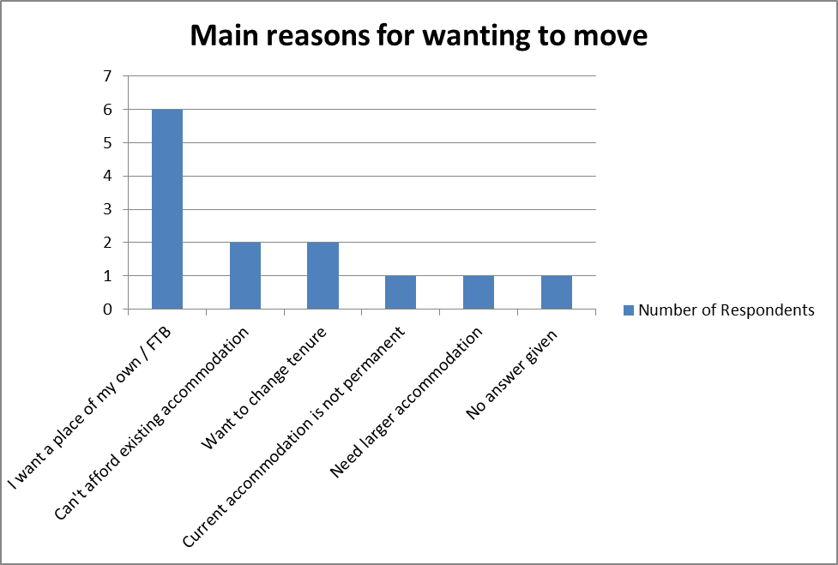

  - Future Housing Needs

The main housing issues that may affect households in three years time are as follows:

  - Household Composition

Of the xx households who responded:

X households (y%) comprise one person;

x households (y%) comprise a couple;

x households (y%) comprise both adult(s) and child(ren);
  - x households (y%) comprise adults sharing a property; and

x households (y%) comprise multi–generational households (most likely to be families), x of these household have one or more person aged 18 or under.

Of these, x households (y%) included a person/s aged 60 years or over.

Of the families in the survey:

x have one child 18 years and under (z%);

x have two children 18 and under (z%) and

x have three or more children 18 and under (z%).

  - Existing Accommodation

The x respondents live in the following:

House type | 1 bed | 2 bed | 3 bed | 4 bed or more | TOTAL
House
Flat
Bungalow
TOTAL

  - Current Tenure

The tenure of the households in the survey is as follows:

Tenure | Number | Percentage
Rent through a Council or Housing Association
Rent privately

Rent from/live with family

Intermediate housing (e.g. shared ownership)
Home Owner with a mortgage

Home Owner without a mortgage

Property tied to employment

Other

OR

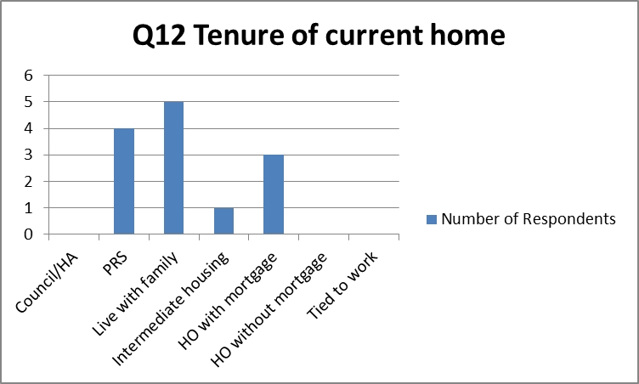

  - Housing Costs
Respondents said that their current rent/mortgage costs (excluding bills) were:

Monthly Costs | Numbers
NIL
£0 - £200
£200 - £400
£400 - £600
£600 - £800
£800 - £1000
Over £1000 per month

  - Current Household Income
The total annual/monthly gross combined income of each household who answered this question was:

Amount | Numbers
Under £20,000 household income per year
(under £1,665 per month)
Between £20,000 and £29,999 per year
(£1,666 - £2,499 per month)
Between £30,000 and £39,999 per year
(£2,500 - £3,332 per month)
Between £40,000 and £49,999 per year
(£3,333 - £4,166 per month)
Between £50,000 and £59,999 per year
(£4,167 - £4,999 per month)
Between £60,000 and £69,999 per year
(£5,000 - £5,832 per month)
Between £70,000 and £79,999 per year
(£5,833 - £6,666 per month)
Over £80,000 household income per year
(over £6,669 per month)

Text analysing the results

  - Accommodation Needed

    - Type and Size

The households in the survey require the following types and size of housing:

Type | 1 bed | 2 bed | 3 bed | 4 bed plus
House

Bungalow

Flat

Adapted or Supported Accommodation
TOTAL

OR

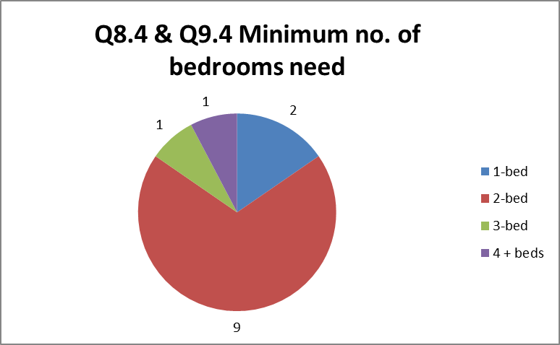

    - Preferred Tenure

The survey results show that people’s first choice of tenure that they thought they could afford were as follows:

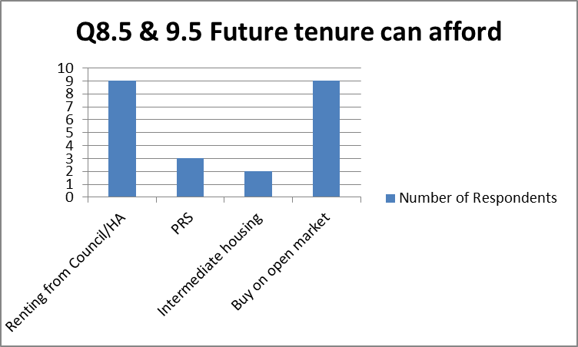

    - Ability to Afford to Purchase Alternative Housing
Of those households who said they had saved a deposit to buy a home, they were able to afford:
Funds (Savings) | Numbers
NIL
£0 – £5,000
£5,000 – 10,000
£10,000 - £15,000
£15,000 - £20,000
Over £20,000

Owner occupiers who responded said they had equity of the following amounts to spend on the purchase of alternative accommodation:
Funds (Equity) | Numbers
NIL
£0 – £20,000
£20,000 – 40,000
£40,000 - £80,000
£80,000 - £120,000
Over £120,000

Text analysing whether people’s savings or equity is sufficient for home ownership and/or intermediate products.

    - Maximum Amount available to spend on rent or mortgage
Respondents said they could afford to spend the following on housing:

Rental Monthly Costs | Numbers
NIL
£0 - £200
£200 - £400
£400 - £600
£600 - £800
£800 - £1000
Over £1000 per month

Mortgage Monthly Costs | Numbers
NIL
£0 - £200
£200 - £400
£400 - £600
£600 - £800
£800 - £1000
Over £1000 per month

Text analysing the implications with reference to properties available on the market in the locality

    - Housing Register

Of the xx respondents, xx (y %) stated they are registered on North Yorkshire HomeChoice

  - What a local Affordable Housing scheme in xxxxx would mean to respondents

As well as the information from the HNS set out above, a number of quotes have been provided from the questionnaire responses. These are direct, anonymised quotes from local people (or people with a local connection to the Parish).

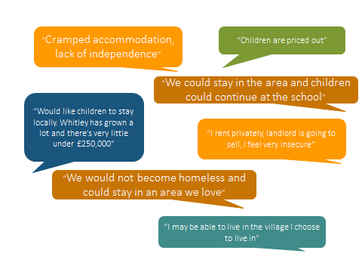

- SUMMARY AND RECOMMENDATIONS

Based on the results of the survey, a mixed tenure development of approximately x no. properties would be appropriate. A mix of mainly x-bedroom, with some x-bed and x-bedroom homes, would reflect the findings of the HNS. However, the final unit numbers and tenure should be reviewed when any scheme is proposed and will be dependent on the site and location. Once a scheme is developed, the homes would be allocated to households with a local connection who were in the highest housing need at that time.

