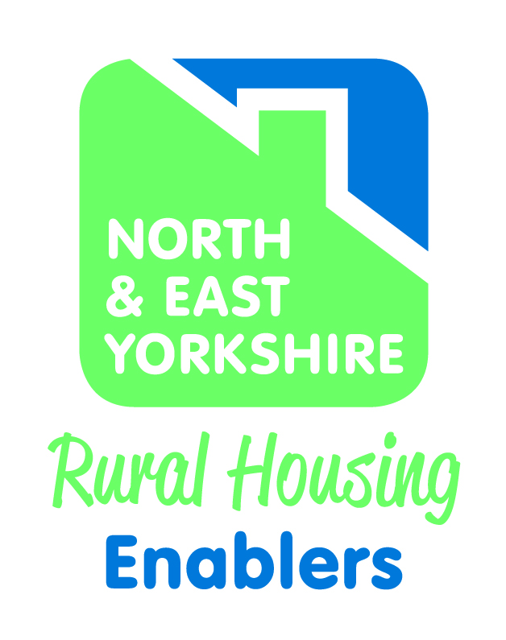

NORTH & EAST YORKSHIRE RURAL HOUSING ENABLER NETWORK

AGENDA ITEM NO: 12

REPORT TO: North & East Yorkshire Rural Housing Enabler Network

DATE: November 2021

SUBJECT: RHE Monitoring and Performance 2021/22

AUTHOR: Colin Huby

1.0 Purpose

  - To report on rural affordable housing delivery for 2021/22 up to the end of
Q2. To list the rural enquiries in Q2 and identify any of these enquiries
for the Community Housing Project.

 |  |  |  | Total | Q1 | Q2 | Q3 | Q4
Forecast Affordable housing completions |  |  |  | 374 | 17 | 14 | 96 | 247
Actual affordable housing completions |  |  |  | 92 | 39 | 53

2.0 N&EY Rural Delivery Programme 2021/22

The Programme forecast for 21/22 = 374*

*This figure has increased from 313 in Q1 with 3 more sites in Craven (total 78 units), 1 site in Hambleton (1 unit) and 18 units reduced at the Kirkbymoorside site in Ryedale after reviewing completion dates for delivery this year.

Rural Programme completions for 2021/22 = 92 to the end of Q2.

This compares to 98 completions at this time last year.

By LA
LA | Completion forecast | Completions actual | % Actual v Forecast
Craven | 132 | 24
Hambleton | 9 | 6
Richmondshire | 8
Ryedale | 74 | 31
Scarborough | 33 | 9
Selby | 14 | 14 | 100%
East Riding | 104 | 8
TOTAL | 374 | 92

By RP:
RP | Completions forecast | Completions actual | Forecast S106 | Forecast Exception | Forecast 100% AH not RES | % Actuals v Forecast
York HA | 19 | 7 | 7 | 12
Broadacres | 9 | 1 |  |  | 9
Yorkshire | 93 | 5 | 25 |  | 68
WDH | 21 |  |  |  | 21
Thirteen Group | 65 | 36 | 83
CDC/Lune Valley | 9 |  | 9
CDC | 10 | 4 | 4 |  | 6
CDC/Jigsaw | 4 | 4 |  |  | 4
Jigsaw | 16 | 16 |  |  | 16
Heylo | 7 | 12 | 7
Hellens | 10 | 7 | 10
Railway | 8 |  | 8
TBC | 14 |  | 14
Private Dev | 4 |  | 4
CLH | 2 |  |  |  | 2
Rentplus | 7 |  | 7
Hull Churches | 4 |  | 4
Housing21 | 72 |  |  |  | 72
TOTAL FORECAST | 374 |  | 164 | 12 | 198
TOTAL ACTUAL |  | 92 | 70 |  | 22
RES/S106 % of Forecast Comps
RES/S106 % of Actual Comps
Total Actual v Total Forecast

Forecast type of site: S106 164, RES 12 and 100% AH 198

Actual delivery by type of site: S106 70, RES 0, 100%AH 22

By NP
Nat Park | Completions forecast | Completions actual | % Actual v Forecast
YDNPA | 24 | 16
NYMNPA | 18
TOTAL | 42 | 16

The total forecast for both Nat Parks has increased from 26 to 42.
YDNPA has an additional site at Long Preston which has now delivered 16 units.

2021/22 Tenure breakdown to Q2

Tenure | F/cast | Actual | % Comp of total
Aff Rent | 168 | 52
Social Rent | 0 | 5
Shared Own' | 165 | 33
DFS | 12
Rent2Buy | 7
Intermediate | 22 | 2
Total | 374 | 92

2021/22 Quarter 2

Forecast completions for Quarter 2 totaled 14

Actual completions for Q2 totaled 53

18 in Craven, 5 in Hambleton, 16 in Ryedale, 9 in Scarborough and

5 in East Riding.

3.0 Rural Enquiries to end of Q2
Craven | 1
Hambleton | 2
Richmondshire | 1
Ryedale | 0
Scarborough | 0
Selby | 0
East Riding | 1
Total | 5

Out of the 5 rural enquiries for Q2, 3 are community led enquiries:

Thorton in Craven. Hudswell in Richmondshire and Homes for Heroes in East Riding.

4.0 Planning consents achieved by LA in 2021/22

Planning consents for Q2 in 2021/22 = 0

LA | Forecasted Consents (affordable) | S106 | RES | 100% AH not RES | Actual Q1 Out | Actual Q1 Full | Actual Q2 Out | Actual Q2 Full | Actual Q3 Out | Actual Q3 Full | Actual Q4 Out | Actual Q4 Full
Craven | 0 | 0 | 0 | 0 | 0 | 0 | 0 | 0
Hambleton | 44 | 0 | 0 | 0 | 0 | 44 | 0 | 0
Richmondshire | 0 | 0 | 0 | 0 | 0 | 0 | 0 | 0
Ryedale | 103 | 103 | 0 | 0 | 0 | 0 | 0 | 0
Scarborough | 36 | 0 | 36 | 2 | 0 | 0 | 0 | 0
Selby | 0 | 0 | 0 | 0 | 0 | 0 | 0 | 0
East Riding | 0 | 0 | 0 | 0 | 0 | 2 | 0 | 0
Total | 183 | 0 | 36 | 2
Actuals |  |  |  |  | 0 | 46 | 0 | 0

Total Outline Actuals |  | 0
Total Full Actuals |  | 46

4.0 Recommendation

N&EYRHE Network members are requested to note and agree the following:

- 92 affordable completions up to the end of Q2
- Forecast completions for 2021/22 = 374
- Planning consents for 2021/22 up to end of Q2 = 46
- 5 new rural enquiries for Q2 with 3 of these CLH enquiries.

