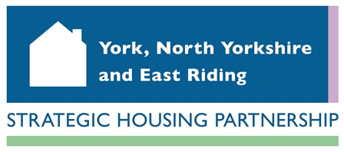
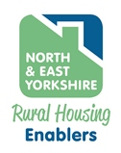

NORTH & EAST YORKSHIRE RURAL HOUSING ENABLER NETWORK

AGENDA ITEM NO: 3b

REPORT TO: North Yorkshire Rural Housing Enabler Network

DATE: 27 April 2016

SUBJECT: NY RHE Programme Forecast 2016/17

AUTHOR: Colin Huby, Rural Housing Enabler

- Purpose

  - To agree a delivery forecast for 2016/17

- The 2016/17 N&EY RHE Programme

  - We are forecasting:
- completions totaling 238 rural affordable homes, across 28 schemes.
- 175 units on S106 sites, 41 units on exception sites and 22 units on sites of 100% affordable housing.

 | Total | Q1 | Q2 | Q3 | Q4
Forecast affordable housing completions 16/17 | 238 | 57 | 4 | 92 | 85
Actual affordable housing completions 16/17

- planning consents totalling 598 rural affordable homes
- 539 on S106 sites, 56 on exception sites and 3 on 100% affordable sites.

 | Total | Q1 | Q2 | Q3 | Q4
Forecast affordable housing consents 16/17 | 598 | 188 | 332 | 24 | 54
Actual affordable housing consents 16/17

- Recommendation

NEYRHE Network members are asked to note and agree the following:
- Total completions forecast of 238 for the 2016/17 RHE Programme.
- Total consents forecast of 598 for the 2016/17 RHE Programme.

