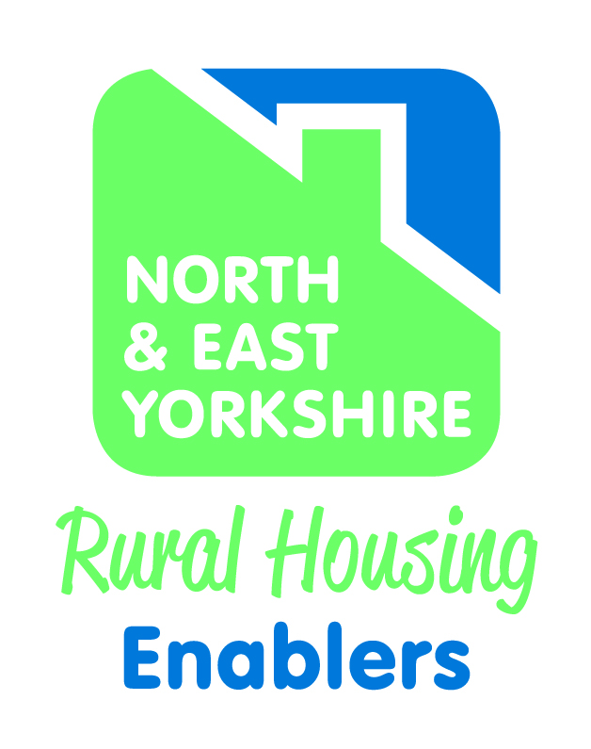

NORTH & EAST YORKSHIRE RURAL HOUSING ENABLER NETWORK

AGENDA ITEM NO: 5

REPORT TO: North & East Yorkshire Rural Housing Enabler Network

DATE: November 2022

SUBJECT: RHE Monitoring and Performance 2022/23

AUTHOR: Colin Huby

1.0 Purpose

  - To report on rural affordable housing delivery for 2022/23 up to the end of
Q2. To list the rural enquiries in Q2 and identify any of these enquiries
for the Community Housing Project.

 |  |  |  | Total | Q1 | Q2 | Q3 | Q4
Forecast Affordable housing completions |  |  |  | 229 | 6 | 16 | 4 | 203
Actual affordable housing completions |  |  |  | 55 | 17 | 38

2.0 N&E Yorkshire Rural Delivery Programme 2022/23

The Programme forecast for 22/23 = 229

This has increased by 54 from 175 in Q1 due to the additional site in Selby

Rural Programme completions for 2022/23 = 55 to the end of Q2.

By LA
LA | Completion forecast | Completions actual | % Actual v Forecast
Craven | 23
Hambleton | 21
Richmondshire | 0
Ryedale | 40 | 22
Scarborough | 4 | 3
Selby | 56
East Riding | 85 | 30
TOTAL | 229 | 55

By RP:
RP | Completions forecast | Completions actual | Forecast S106 | Forecast Exception | Forecast 100% AH not RES | % Actuals v Forecast
York/Karbon | 56 |  | 2 |  | 54
Beyond Housing | 18 |  |  | 18
Yorkshire | 31 | 22 | 2 |  | 29
WDH | 40 |  | 17 |  | 23
Thirteen Group | 38 | 17 | 38
Rentplus | 1 | 1 | 1
CLH | 2 | 3 |  |  | 2
Auxesia | 6 | 8 | 6
Heron EF | 6 |  |  |  | 6
Together | 9 |  | 9
TBC | 10 |  | 10
Railway | 6 |  | 6
Hellens | 2 |  | 2
Private Dev | 4 | 4 | 4
TOTAL FORECAST | 229 |  | 97 | 18 | 114
TOTAL ACTUAL |  | 55 | 32 |  | 23
RES/S106 % of Forecast Comps
RES/S106 % of Actual Comps
Total Actual v Total Forecast

Type of site: S106 97 Exception 18 and 100% AH 114

The NYMNPA has a forecast of 6 affordable units and has completed 5 in Q1
The YDNPA has a forecast of 0 affordable units for 22/23

2022/23 Tenure breakdown for Q2

Tenure | F/cast | Actual | % Comp of total
Aff Rent | 114 | 24
Social Rent | 8
Shared Own' | 55 | 22
DFS/DMS | 4 | 2
Rent2Buy | 31 | 1
Intermediate | 17 | 6
Total | 229 | 55

2022/23 Completions in Quarter 1 and 2

Forecast completions for Quarter 1 totaled 6
Actual completions for Q1 totaled 17

5 in Ryedale, 3 in Scarborough and 9 in East Riding.

Forecast completions for Quarter 2 totaled 16

Actual completions for Q2 totaled 38

21 in East Riding and 17 in Ryedale

3.0 Rural Enquiries to end of Q2

Craven | 1
Hambleton | 0
Richmondshire | 0
Ryedale | 7
Scarborough | 0
Selby | 0
East Riding | 2
Total | 10

Out of the 10 rural enquiries for Q2, none are community led enquiries.

There were 3 rural enquiries in Q1 again none were CLH ones.

4.0 Planning consents achieved by LA in 2022/23

Planning consents for Q1 in 2022/23 = 11
Planning consents for Q2 in 2022/23 = 27

LA | Forecasted Consents (affordable) | S106 | RES | 100% AH not RES | Actual Q1 Out | Actual Q1 Full | Actual Q2 Out | Actual Q2 Full | Actual Q3 Out | Actual Q3 Full | Actual Q4 Out | Actual Q4 Full
Craven | 52 | 50 | 0 | 2 | 0 | 0 | 5 | 0
Hambleton | 34 | 34 | 0 | 0 | 0 | 0 | 0 | 17
Richmondshire | 0 | 0 | 0 | 0 | 0 | 0 | 0 | 0
Ryedale | 92 | 73 | 19 | 0 | 0 | 0 | 0 | 0
Scarborough | 30 | 0 | 30 | 0 | 0 | 0 | 0 | 0
Selby | 60 | 60 | 0 | 0 | 0 | 0 | 0 | 0
East Riding | 104 | 40 | 44 | 20 | 0 | 11 | 10 | 0
Total | 372 | 257 | 93 | 22
Actuals |  |  |  |  | 0 | 11 | 10 | 17

Total Outline Actuals |  | 10
Total Full Actuals |  | 28

4.0 Recommendation

N&EYRHE Network members are requested to note and agree the following:

- 17 total completions up to the end of Q1
- 55 total completions up to the end of Q2
- Revised forecast completions for 2022/23 = 229
- Planning consents for 2022/23 to Q2 = 38 (10 outline/28 full)
- 10 rural enquiries for Q2 with none being CLH enquiries

