ENABLING AFFORDABLE COMMUNITY-LED HOUSING IN NORTH YORKSHIRE AND EAST RIDING

STATUS REPORT

1. Introduction

This short report comes at the start of an important project aimed at stimulating community-led affordable housing in North Yorkshire and East Riding, to complement more traditional provision by housing associations and local authorities and increase the delivery of affordable homes across the sub region. The work is being carried out by Social Regeneration Consultants and this is the first output of the commission.

The report explains what community-led housing is and provides a brief overview of activity across the country. It outlines recent changes in legislation and central government policy that provide new opportunities for this type of housing provision.

The report sets out the current position in North Yorkshire and East Riding and the opportunities for community-led housing that will be explored in more depth over the next six months.

Finally, the report provides pointers to a range of successful community-led housing schemes in other parts of the country that may help to stimulate interest amongst local communities and stakeholders in this part of the world.

2. What is community-led housing?

Community-led housing has five main features:

- It is usually small scale – most schemes are under 20/25 homes and some are much smaller

- Schemes are usually set up and run by local people in their own communities, often with external support from housing associations, local authorities or regional and national support organisations

- It provides genuinely affordable homes for rent, shared ownership or sale on sites that are often difficult for mainstream housing providers to develop

- Schemes meet long-term local housing needs, by the community retaining a legal and/or financial interest in the homes provided and ensuring they are always available to local people who need them

- Community-led housing is not for profit, involving considerable voluntary effort

Community-led housing comes in many shapes and sizes – there is no standard model:

Community Land Trusts provide affordable homes for local people in need – for rent or shared ownership - by acquiring land and holding it as a community asset in perpetuity

Housing Co-operatives involve groups of people who provide and collectively manage affordable homes for themselves as tenants or shared owners

Cohousing schemes involve groups of like-minded people who come together to provide self-contained, private homes for themselves, but manage their scheme together and share activities, often in a communal space

Tenant management organisations provide social housing tenants with collective responsibility for managing and maintaining the homes through an agreement with their council or housing association landlord

Self-help housing projects involve small, community-based organisations bringing empty properties back into use, often without mainstream funding and with a strong emphasis on construction skills training and support

Community self-build schemes involve groups of local people in housing need building homes for themselves with external support and managing the process collectively

There are overlaps between these different models; for example, some co-housing schemes operate as co-operatives. A number of Community Development Trusts, set up to acquire and/or build community assets, but without a specific housing focus, are also now beginning to initiate community-led housing schemes in their areas.

Each community-led housing ‘model’ has its own national umbrella body that promotes and supports the sector.

National Community Land Trusts Network www.communitylandtrusts.org.uk
Confederation of Housing Co-operatives www.cch.coop
The UK Cohousing Network www.cohousing.co.uk
National Association of Tenant Management Organisations www.natmo.com
Self Help Housing www.self-help-housing.org
The Community Self Build Agency www.communityselfbuildagency.org.uk
Locality (formerly the Development Trusts Association) www.locality.org.uk

3. The national picture

Community-led housing represents just under 1% of the nation’s housing stock, so it is a very small part of housing provision in this country. In comparison, 10% of the housing stock in some European countries is community-led.

In England, there are around 170 community land trusts (CLTs), many of which have only been up and running for three years or more. Most are to be found in rural communities, but there is now a growing urban CLT sector too. There is an expectation that 3000 affordable homes will have been provided through CLTs by 2020.

There are more than 1000 housing co-operatives and other mutuals, managing around 200,000 homes. Many of these co-ops were set up in the 1970s and 1980s when they were particularly in vogue.

More than 54 cohousing schemes are currently completed or under development in England and interest in them is growing, particularly amongst young single people and older people, in both urban and rural areas.

There are more than 130 tenant management organisations, mainly in council-owned housing estates in urban areas and more than 120 self-help housing groups, also mainly urban based but often established in inner city areas of older private housing.

And finally, around 100-150 homes a year are currently being provided through community self-build, as part of the self-build/custom build sector.

There is currently a move to bring the different parts of the community-led housing sector together, to form a national alliance, taking advantage of a generally supportive policy environment and the potential for ‘scaling up’ provision across the country. This work is being led by the Building and Social Housing Foundation, with funding through the Nationwide Foundation.

There are differing views in the community-led housing sector on the most effective way of ‘scaling-up’ provision. These can be summarised as:

- Bottom up, grass roots, volunteer-led community groups responding to housing need, or people seeking to deliver their own homes

- An extension of activity by existing community-led or based organisations

- Developer led/top down initiatives by local authorities, housing associations, landowners and small builders wanting to provide housing that benefits their local area, with communities coming on board once sites and funding are in place

All three approaches have a place in scaling up community led housing nationally, and particularly in areas like North Yorkshire and East Riding, where activity is at a very low level.

4. Recent legislative, policy and funding changes

There have been some significant changes over the past year that are already having a direct impact on affordable housing provision across the country. The extension of a ‘voluntary right to buy’ to most housing association tenants, the 1% annual rent reduction for most housing association tenancies and the extensive reforms to welfare provision have all had a major impact on housing association business plans. Local authorities have also been affected by the requirement to sell off their most valuable housing stock as it becomes vacant.

The Government’s commitment to increase house-building to meet a national shortfall of up to 250,000 homes a year for the foreseeable future is heavily focused on expanding home ownership. The Homes and Communities Agency’s £4.7 billion Shared Ownership and Affordable Homes Programme 2016-2021 will see 95% of the funding spent on a range of low cost home ownership schemes by housing associations and developers, with funding for affordable rent largely limited to supported housing.

Whilst some larger housing associations have been intending to use their reserves to continue delivering affordable rented homes in priority areas and some local authorities are making use of Section 106 funds to do the same, there is now little doubt that future provision of affordable rent schemes will be severely restricted, with those going ahead potentially affected by right to buy in future years.

These changes will certainly have an impact on rural affordable housing provision. Many communities in rural towns and villages are reluctant to accept new housing development, particularly if it is seen to be only of benefit to outsiders with no local connection. The growth of second homes is often a particular concern. Young people are priced out of the market and forced to move away whilst older people wishing to downsize find there are few suitable properties available locally. Anyone on below average earnings, needing rented accommodation, is also in a very difficult position. Many rural businesses are consequently finding it increasingly difficult to attract and maintain a local workforce.

Community-led housing is not a complete solution to these problems but it does offer a very different and attractive option. This has now been recognised by Government. The March 2016 budget made a commitment to provide £60 million a year for five years to support community-led housing in rural and coastal communities. One third of this is to be specifically targeted at South West England, where current activity is particularly strong, but at the time of writing there are no other details of how and where this fund is to be distributed. There are however indications that the focus will be on low cost home ownership rather than affordable rent schemes and on areas with particular pressure from second home owners. Funding may well be dispersed through local authorities rather than the Homes and Communities Agency.

The Government has also agreed to effectively exempt community land trusts and housing co-operatives from its extended Right to Buy provisions, accepting the argument that community-led schemes will not happen unless the homes they provide are available on an affordable basis to local people in perpetuity. Community Land Trusts working with housing associations have also secured an exemption from the 1% rent reduction for at least 2016/17, which will lessen the adverse impact on their own business plans.

Alongside capital funding from government, a number of national lenders are now actively supporting community-led housing schemes with development and mortgage finance. Charity Bank and Ecology Building Society are leading the way, but there are others too. Start up grants and loans, through Locality and the National Community Land Trust Network are also available, as is initial cost-free specialist advice and support in the early stages. There are also indications that revenue funding for regional support agencies – both existing and new – may form part of the Government’s rural and coastal communities programme.

Some local authorities are also providing revenue and capital funding for community-led schemes and, on larger sites, there is an increasing emphasis on cross subsidy between market sale and affordable rent/shared ownership, with developers and local communities working in partnership to get schemes off the ground.

5. The current position in North Yorkshire and East Riding

The area has managed to deliver 600 affordable homes a year, with a focus on Section 106 funding and Rural Exception sites outside the urban areas. The well-supported network of Rural Housing Enablers has been successful in bringing most of these schemes to fruition. Nevertheless, 600 affordable homes are year is widely regarded as a significant under-supply at a time when need and demand are both increasing.

One of the key priorities in the York, North Yorkshire and East Riding Housing Strategy 2015-2021 is to increase the supply of affordable homes across the area to around 1,600 a year, partly by enabling and supporting self build, custom build and community-led housing.

Although there is growing interest in some communities in community-led housing across the sub region, only two schemes are currently ‘active’ – one in Hudswell, Richmondshire (three affordable homes for young families being developed by a community charity), and the other in Selby (a cohousing scheme for over 55s on a smallholding site). Activity here is clearly starting from a low base.

The map on the following page shows the current level of community-led housing activity across the country and highlights the absence of it across most of North Yorkshire and East Riding. The area is similar, in many respects, to other high value rural areas in England where community-led housing is now well-established.

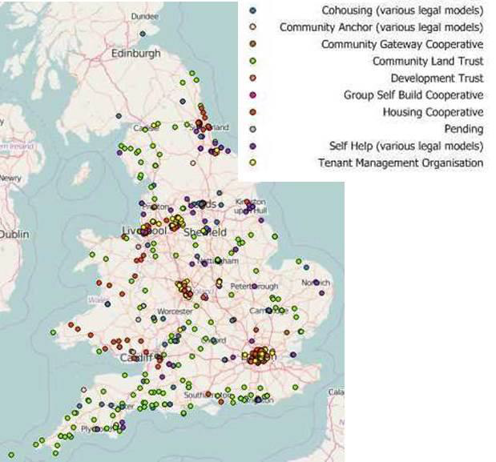

So why is activity in this area so low? There are three basic reasons:

- No-one has been actively promoting it
- Most local communities are unaware of it
- There is no organisation in the area currently able to support it

Despite these limitations, the North Yorkshire and East Riding sub region is now in a good position to develop a programme of community-led housing, for the following reasons:

i) There is growing interest amongst a number of local authorities and housing providers, keen to add an additional mechanism for delivering more affordable homes in rural communities

ii) Most, if not all of the area is likely to qualify for capital funding through the Government’s £60 million a year Rural and Coastal Community Led Affordable Housing Programme

iii) There may be revenue funding within this £60 million programme for setting up an appropriate support mechanism that could promote and develop community-led schemes

iv) The well-supported network of Rural Housing Enablers with their on-the-ground knowledge is the key to generating potential schemes

v) Neighbourhood planning activity is reasonably active across North Yorkshire and East Riding. There are around 27 Neighbourhood Plans at various stages of development here and they can act as a useful catalyst for community-led housing where housing is a key issue

