York & North Yorkshire Housing Board

Monday 18 September 2023: 1:00pm
Teams

PRESENT:
Cllr Simon Myers NYC (Chair)  Cllr Burton - CYC  Michael Jones – CYC  Andrew Rowe - NYC  Hannah Heinemann - NYC | Richard Panter - Homes England  Clair Shields – NYMNPA  Linda Marfitt – NYC  Andrew Leeming – YNYLEP  Peter Stockton – YDNPA | Michelle Saunders – NYC  Matthew Good – Pegasus Planning

 |  | ACTION
1.0 | Apologies – Neil Ferris, Tracey Carter, Nick Atkin, Nic Harne, Cllr Pavlovic, Tamsin Hart Jones, Chris France, Rachel Richards
2.0 | Minutes of the last meeting (6 March) and matters arising  Minutes agreed.  AR asked for an update on the York university work. SG to ask Liz Small for an update at the next meeting. | SG
3.0 | NYC update on structures – Andrew Rowe & Linda Marfitt  Andrew and Linda updated Board on new structures for both housing and planning within the new Community Development Directorate at NYC.  Priorities are to focus on bringing eight teams into one – restructuring c. 440 staff within housing services over the next six months. Challenges include:  - Efficiencies and resilience, need for savings to the general fund.  - Ensuring quality of service.  - Harmonising KPIS and targets.  - Maximising opportunities to join up with social care.  - Preparing for new social housing regulation.  - Governance structures for the new landlord.  In terms of planning:  - There are new committee structures in place across the six locality areas, which are aligned to political constituencies.  - Work is underway on a new Local Plan for NY and there is a commitment to have an adopted Local Plan in place within five years.  - A HEDNA is soon to be commissioned as part of this process.  - A Statement of Community Involvement is due out in October.  - A call for sites will be issued in the new year.  - An issues and options consultation is planned for the end of 2024.  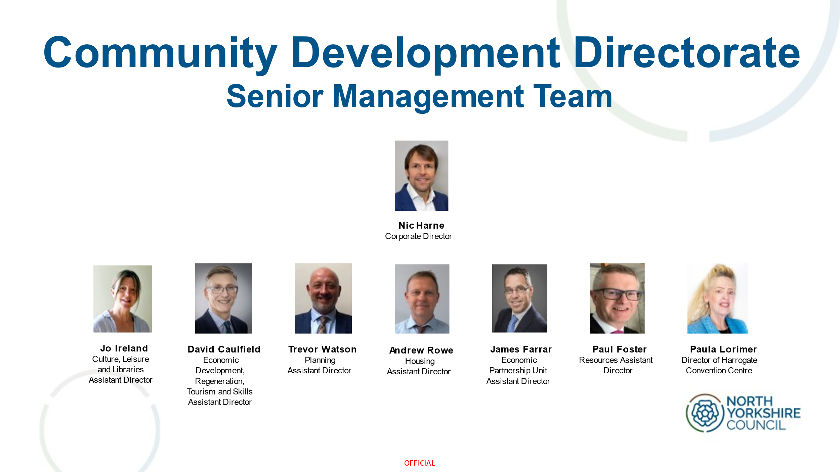  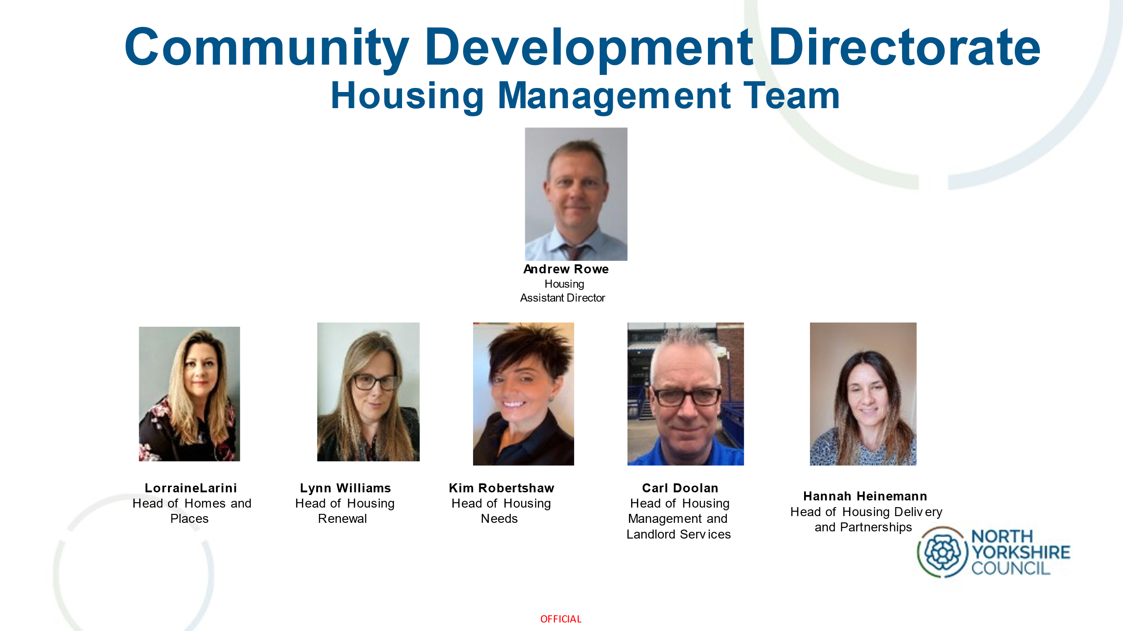  See slides circulated with minutes for more detail.  http://nycyerhousing.co.uk/home/governance/housing-board-papers/
4.0 | Draft NYC Housing Strategy – Sharon Graham  The draft Housing Strategy covers the period 2024 to 2029 and sets out a vision to deliver ‘good quality, affordable and sustainable homes that meet the needs of all our communities’.  Priorities are set out around three key themes:  - our people:  - preventing and tackling homelessness  - meeting the needs of our ageing population  - meeting supported housing needs and the needs of specific groups  - our places:  - Growing the supply or affordable and available housing  - Addressing the rural housing crisis  - Supporting communities through neighbourhood renewal and regeneration  - our homes:  - decarbonising our whole housing stock  - ensuring that new housing supply contributes to our net zero housing ambitions  - addressing stock condition issues  - ensuring that council homes remain decent and continue to improve  See slides circulated with minutes for more detail:  http://nycyerhousing.co.uk/home/governance/housing-board-papers/  The formal consultation process for the draft Strategy runs from 2 October until 11th December 2023. The link to the online draft Strategy and consultation survey can be accessed here:  https://www.northyorks.gov.uk/your-council/consultations-and-engagement/current-consultations/draft-housing-strategy-consultation
5.0 | Devolution update and Brownfield housing Fund – Andrew Leeming  Devolution Deal:  Powers:  The Y&NY MCA will:  - Have broad powers to acquire and dispose of land to build houses, commercial space and infrastructure, for growth and regeneration;  - Be able to invest to deliver housing for the area;  - Have land assembly and compulsory purchase powers;  - Have the power to designate a Mayoral Development Area and to create Mayoral Development Corporations, which will support delivery on strategic sites in York and North Yorkshire  Funding:  The Y&NY MCA will be awarded:  - £12.7 million of devolved capital funding across 2023/24 and 2024/25 to support the building of new homes on brownfield land;  - £347,000 in capacity funding across 2023/2024 and 2024/2025 to support the York and North Yorkshire Combined Authority to identify and bring forward a pipeline of housing projects;  - A one-off investment in York and North Yorkshire of up to £2.65 million specifically to pilot new energy efficiency or shared ownership schemes.  Working with Homes England:  York and North Yorkshire and Homes England are committed, with the support of DLUHC, to working collaboratively to unlock the barriers to:  - Rural affordable housing delivery,  - The regeneration of market towns and wider housing growth through the development of a pipeline for the region.  This will be underpinned by a clear Action Plan.  Homes England and DLUHC will explore:  - the potential for investing in the delivery of this pipeline  - With the combined authority how wider measures – including viability assessments and the planning system – could better support York and North Yorkshire’s plans to increase much needed rural affordable housing supply, and in partnership test how the developing Homes England rural strategy could assist in this.  What we need to do:  - Deliver the Brownfield Housing Fund successfully;  - Prepare a housing strategy and prospectus for York and North Yorkshire identifying:  - Strategic site opportunities  - Affordable Rural housing supply  - Low carbon housing solutions  - Formulate future asks for CSR and Deal 2  - Provide resource and capacity with Homes England to develop the strategic opportunities  - How Housing will fit into the MCA Governance  Brownfield Housing Fund:  - Projects in Appraisal  - Recommendations will be made to JC in November  - Discussions with applicants will follow appraisals and JC decisions  - Approvals December/January  - MCA formed January
6.0 | Homes England Update – Richard Panter  Affordable Homes programme 21-26:  - Implemented flexibilities to include social rent available everywhere and now a government priority;  - Change in balance of tenure of programme to be more in favour of rented (affordable and social) approx 70/30;  - Larger allowance of proportion of the programme to be delivered via off the shelf/purchase and repair (approx 30%);  - Flexibilities to pay up to 90% of grant at acquisition/start on site dependent on spend;  - Programme targets and Strategic Partner contracts revised to reflect greater grant cost of social rent and the current market.  The Affordable Homes Programme CME bidding route remains open for new business and there is a healthy pipeline. We are currently seeing a lot of Off the Shelf and package deals as developers revise their strategies.  A major recent additional change is the ability to fund replacement as well as additional affordable homes on regeneration schemes Turbo-boost for estate regeneration with major change to the Affordable Homes Programme - GOV.UK (www.gov.uk). This is funded through the existing AHP budget. Projects must start by March 2025.  Another major announcement is the availability of Brownfield Infrastructure land Funding ( BIL). This is a flexible tool designed to complement the agency’s focus on place and to deliver the new Strategic Plan Brownfield, Infrastructure and Land Fund - GOV.UK (www.gov.uk) Homes England strategic plan 2023 to 2028 - GOV.UK (www.gov.uk)
7.0 | Y&NY Housing Partnership update  Item deferred to next meeting. | NA/GT
8.0 | National Parks update  NYMNPA – CS advised that the NYMNPA Management Plan has a target to double number of homes delivered and working with RHEs on a number of Rural Exception Sites at the moment. Issues with delivery, including Parish Council objections. Cllr Myers offered assistance with enabling delivery. 200 homes have been built in Helmsley but the NP has still experienced population decline.  YDNPA – PS reported that YDNP has lost 4% of its population since 2011 and that 30% of the Park’s population is over 65. The new Local Plan is seeking to mitigate the trend of population decline. In March the YDNPA published a list of 33 potential housing sites, with the potential to deliver 600 homes. There is a target to deliver 750 homes over the 15-year Local Plan period. There were a number of objections to the published list and there are challenges linked to site distribution, with a paucity of sites in the west and north of the Park. A Member Working Group is currently reviewing the site allocations and Local Plan approach to meeting housing need.
9.0 | House Builders update  MG advised that there are tough market conditions for house builders at present. House prices are coming down as cost-of-living impacts. There is nervousness from house builders as to whether they can deliver the sites that they have. Sales have dropped from one per week to one per month.  Uncertainty regarding the Local Plan position in NY was unhelpful and clarity around the Selby locality Local Plan would be useful. LM advised to keep a watching brief on Exec Member briefings. MG will circulate the updates from AR and LM to HBF members. National policy, delays to the LURB not helping. It would be helpful to understand what is happening in terms of the overall picture in terms of planning consents and completions. LM advised that there were 3,500 completions in NY in 2022/23. | MG
10.0 | Agenda items for future meetings  - Add CYC update to agenda as a standing item  - MJ requested that there is a focus to delivery on LA updates
11.0 | AOB  MJ advised that the CYC Local Plan is close to being adopted.
12.0 | Date of next meeting  4th December 2023  13:00-15:00  Teams

